Mandatory Disclosure



Thapar Polytechnic College
(ESTD.1956)
(Managed By Thapar Education Trust, New Delhi)
Thapar University Campus,
Patiala-147004
Ph. 0175-2365554

Website: www.tpc.ac.in
E-mail: principaltpc@thapar.edu
Mandatory Disclosure
- Name of the Institution:
Name | Thapar Polytechnic College
City | Patiala
District | Patiala
Pin Code | 147004
State | Punjab
Phone No. With STD Code | 0175-2365554
Fax. No./E-Mail | principaltpc@thapar.edu
Nearest Railway Station | Patiala City (3 km)
Nearest Airport | Chandigarh
Website | www.tpc.ac.in

- Name & Address of the Principal
Name | Dr. Ankush Kansal
Designation  Principal | Date of Birth: (Age)  08-09-1977 | Highest Degree  Ph.D | Specialization  Electronics & Comm. Engg. | Total Experience (Years)
 |  |  |  | Teaching | Research Industrial | Academic Administration
 |  |  |  | 18 | - | -
Mobile No. | STD Code  0175 | PAN No. | AKCPK9746K
Phone/Fax No.  2365554 | Phone No. (O) | Date of relieving from last job:  12 July 2006
E-mail:  principaltpc@thapar.edu | Phone No. (R) | Date of Joining the institution:  13 July 2006

- Name of Affiliating University:

Punjab State Board of Technical Education & Industrial Training
Plot No. 1-A, Sector 36 A,
Chandigarh

- Governance/Management
The Institution is managed by the Managing Committee formulated and approved by the Patiala Technical Education Trust.
- The present composition of Managing Committee is as follows:-
S.No. |  | Name(S/Shri/Ms) | Designation
1. |  | Dr. Prakash Gopalan  Director  Thapar University Patiala | Chairman
2. |  | Sh. J.S. Neerav  Executive Director (Education Initiatives)  C/o Avantha Holdings Ltd.  Ballarpur Industries Limited  First India Place, Tower -C 3rd Floor  Mehrauli-Gurgaon Road  Gurgaon-122002 | Member
3. |  | Dr. Padmakumar Nair  Director  LMT School of Management  Dera Bassi Campus  Thapar University  Dear Bassi (Mohali) | Member
4. |  | Sh. Vinod Kumar Sablok,  Vice President & Head Legal  C/o. Avantha Holding Limited  Ballarpur Industries Limited  First India Place, Tower-C, 3rd Floor  Mehrauli –Gurgaon Road  GURGAON -122002 (HARYANA) | Member
5. |  | Dr R S Kaler  Deputy Director  Thapar University, Patiala | Member
6. |  | Secretary to Govt. of Punjab  Deptt of Tech. Edu & Indl. Training  Mini Secretariat, Sector-9  Chandigarh or nominee Ex-Officio | Member
7. |  | Director  Technical Education & Industrial Training, Punjab  Plot No- 1, Sector 36-A  Chandigarh or nominee Ex-Officio | Member
8. | Chairman  Punjab State Board of Tech. Edu. & Industrial Training, Punjab  Plot No- 1, Sector 36-A  Chandigarh or nominee Ex-Officio |  | Member
9. | Regional Officer  All India Council for Technical Education  North Western Regional Office  Plot No.1 Sector 36-A  Chandigarh or nominee Ex-Officio |  | Member
10. | Joint Education Advisor (T)  Deptt of Education  Ministry of Human Resources Dev.  Shastry Bhawan  New Delhi or nominee Ex-Officio |  | Member
11. | Dr. Gurwinder Singh  Registrar  Thapar Institute of Engg. & Tech.  Patiala |  | Member
12. | Dr. Anurag Joshi  Head of Department  Electrical Engg.  Thapar Polytechnic College Patiala  (Teacher’s representative from amongst the Head of the Departments in order of Seniority, by yearly rotation) |  | Member
13. | Principal  Thapar Polytechnic College  Patiala |  | Member Secretary

- Frequency of Board Meetings
Managing Committee meetings are held twice in a year.
- Organization Chart and Processes
Librarian
T.P.O.
Supporting Staff
Administrative Deptt.
Lecturers
HODs
Governing Body
Principal

- Nature and extent of involvement of faculty and students in academic affairs/improvements.
The members of faculty and students are actively involved in academic affairs. Various personality development programmes for students are organized frequently. The members of faculty are also sponsored to attend short term courses for quality improvement.
- Mechanism/norms and procedure for democratic/good governance.
In order to maintain the accountability, we conduct an internal Audit every Semester at departmental and Inter departmental level. We are applying horizontal system of Administration. For having democratic good governance, in this system there are several functional heads, who are accountable for their jobs responsibilities, and they are fully authorized to take work from their subordinates and colleagues. In case of any indiscipline by a subordinate they can report against him to the institutional head i.e. the Principal.
- Student Feedback on Institutional Governance/Faculty Performance
Student feedback on Institutional Governance/Faculty Performance is obtained once in a semester. Students are always welcomed to report their grievances to their concerned HOD’s and Principal. From session 2009, Internal Rationalization Committee has been constituted to seek feedback on Institutional level.
- Disciplinary Committee/Grievances Redressal Mechanism for faculty, staff & student:
Disciplinary Committee
Name | Designation
Dr. (Mrs.) Ritu Jindal, Head (App. Sciences) | Convener
Mr.Rajesh Premi | Member
Mr. Vaibhav Singhi | Member
Mr. Harmeet Singh | Member
Ms.Aman Singla (Hostel Warden –F) | Member
Mr. Yadwinder Singh | Member
Ms. Mehak Khurana | Member
Ms. Monika Gupta | Member
Mr. Harinderjit Singh (Hostel Warden-D) | Member
Ms. Shama Sethi | Member
Grievance Redressal Committee
Name | Designation
Dr. Anurag Joshi  HEED | Convener
Mrs. Shashi Bala  Lecturer, Comp Engg. | Member
Ms. Anmol Rattan  Lecturer, Civil Engg. | Member

- Programmes
Name of the Course | Affiliation | Sanctioned Intake | Duration | Session
Architecture Assistantship | Yes | 60 | Three Years | Morning
Civil Engineering | Yes | 60 | Three Years | Morning
Electrical Engineering | Yes | 60 | Three Years | Morning
Mechanical Engineering | Yes | 60 | Three Years | Morning
Computer Science & Engineering | Yes | 120 | Three Years | Morning

- PLACEMENT FACILITIES
We have a full-fledged Training & Placement cell which plays an important role in counselling the students regarding their career and placements. On an average 70 - 80% of our eligible students got placements in the past three years.
We have assigned one staff member from each department/trade as representative of TP cell to assist the students and recruiters during campus placements and other activities organized by training and placement cell.
Our Recruiters
 |  |  |  |  | 

- Name and duration of programme(s) having affiliation/collaboration with Foreign University(s)/Institution(s) and being run in the same Campus along with status of their AICTE approval. If there is foreign collaboration, give the following details:
-----------------------------------N.A------------------------------------
- Details of the Foreign Institution/University:
Heraud Education, South Australia
- For each Collaborative/affiliated Programme give the following:
Building & Construction
- Whether the Collaborative Programme is approved by AICTE? If not whether the Domestic/Foreign Institution has applied to AICTE for approval as required under notification no. 37-3/Legal/2005 dated 16th May, 2005
-----------------------------------N.A. ------------------------------------
PROFILE OF DIRECTOR/PRINCIPAL WITH QUALIFICATIONS, TOTAL EXPERIENCE, AGE AND DURATION OF EMPLOYMENT AT THE INSTITUTE CONCERNED
(Details of Contribution in Engineering Research, Educational Management and Literature)
- Name Dr. Ankush Kansal
- Father’s Name Sh. Janak Raj Kansal
- Educational Qualification Ph.D, M.E.(ECE), B. Tech (ECE),
- D.O.B 08-09-1977
- Specialization Electronics & Comm. Engg.
- Nationality Indian
- Present Employment Principal
Thapar polytechnic College,
Patiala
- E.mail Address principaltpc@thapar.edu
- Teaching Experience 18 Years
- Industry Experience --

- FEE
Collection of fee is incorporated by the Institution as per the guidelines and Approval by the State Board fee Committee.
FEE STRUCTURE OF THE INSTITUTION
S. No Details Amount (in Rs.)
Board’s Charges
1.Registraton Charges(one time) 500.00

Collection on behalf of institute
2.Tution Fee (Half yearly) 11000.00
3.Refumdable Security(One Time) 500.00
4.Development fund (Yearly) 3,650.00
5.Student Activity Fund (Yearly) 2,235.00
Student Activity Fund (One Time) 265.00
___________
Grand Total 18150.00
- The student of Sc/ST category of Punjab shall pay only Rs.1133/-at the time of admission subject to the condition that family annual income is less than Rs.4,00,000.
- Refundable Security 633
- Registration Charges 500
- Student activities related fund 150 (House Exam & Sports Fee)
In case a SC candidate not having the proof of the income shall pay the fee as per other categories.

Detail of Student activities related fund

a) Student Fund 665/- PA
b) Annual/culture fund 67/- PA
c) Audio Visual 67/- PA
d) Common Room /club 67/- PA
e) Library fund 133/- PA
f) Magazine charges 33/- PA
g) NCC/NSS 33/- PA
h) Cycle /Scooter charges 133/- PA
i) Medical fund 67/- PA
j) Drawing Board 133/- PA
k) General maintenance 667/- PA
l) Recreation 68/- PA
m) Student chapter 35/- PA
n) Stationary Charges 67/- PA

(I) Total (a to n) 2235/- PA

o) Valedictory fund 66/- One Time
p) Identity Card 66/- One Time
q) Refundable Security 133/- One Time

(II) Total (o to q) 265/- One Time

(III)Grand Total (I+II) 2500/-
In addition to the above fee structure, Govt of Punjab has formulated a comprehensive insurance scheme for the benefit of student to the polytechnic. The charges for the same shall be collected at the level of institute. (Rs. 200 for General category and Rs. 150 for SC category)
- Time schedule for payment of fee for the entire programme.
Semester wise fee is taken in the month of January and July every year
- FEE WAIVER SCHEME
As per Punjab Government notification no.13/60/08-ITE2/2650 dt. 24.6.10, 5% additional seats shall be given to the following categories:
A. Women Candidates
B. Economically Weaker
C. Physically Handicapped
For every group of 60 sanctioned intake, 03 additional seats will be given which will be allocated for the above categories. In the event of non availability of student in a specific category as above, the benefit will be given to any other category according to merit.
Admission/Eligibility Matric passed children of parents having annual income less than Rs.8.00 lakhs from all sources shall only be eligible for seats under this scheme. For the students admitted under this scheme, only tuition fee shall be completely waived off. The tuition fee waiver to a student shall be for the complete duration of the course.
Note: All these seats shall be over and above the sanctioned intake. This scheme is only applicable to residents of Punjab.
Scholarships are given to the students on the basis of merit cum means.
- Estimated cost of boarding and lodging in Hostels.
(w.e.f July 2020 Academic Session 2020-21)
Room Rent Rs.35,100 per annum
Security Rs.6,000 One Time, refundable

Mess Charges Rs. 1,800 per month
Mess security: 1,000 non refundable (One Time)
2000 refundable (One Time)
- Document Retention Policy

S. No. | Certificates: | Original/Photo Copy | Remarks
1. | Qualifying Examination Detail Marks Sheet | Photo copy
2. | Matriculation Certificates (Date of Birth) | Photo copy
3. | Character Certificate from institutions last attended | Photo copy
4. | Proof of Residence/Domicile Certificate | Photo copy
5. | Certificate in support of claim under reserved category. | Photo copy
6. | Income Certificate, if admitted under Tuition Fee waiver seat/Reserved Category in support of claim under reserved category. | Original | Original for SC/ST reserved category
7. | Attested copies of above certificates | Photo copy
8. | Two recent stamp size photograph | Original

Candidates who fail to produce the requisite documents will not be admitted.

- Reservation:
The reservation of seats for institutes situated in Punjab shall be as per Punjab Government, Department of Technical Education and Industrial Training. A candidate shall be eligible to make claim for reservation under one reserved category only. However, the procedure for counselling/ allotment of courses and/ or institutes shall be such that if a candidate is getting a course/ institution higher in his/ her order of preference, as a general candidate, he/she shall be so regarded, notwithstanding his/ her claim as a reserved category shall then be offered to the candidates in that very reserved category. Reserved categories candidates must attach photo copy of the certificate as proof thereof along with admission form. Certificate to be produced by a candidate belonging to Backward Class of Punjab in support of his/ her claim under this category must not be dated earlier than one year before the first day of counselling for admission. The percentage of reservation for each of the categories shall be now as under:-
S. No | Category | Percentage
1 | Scheduled castes/ schedule tribes | 25%
2 | Backward classed | 5%
3 | Border Areas/ backward areas | 4% (2% each)
4 | Sports persons | 2%
5 | Disabled Persons:  - Blind  - Deaf & Dumb  - Other Handicapped | - 1%  - 1%  - 1%

- AICTE Approval (LOA & EOA)
  - Number of seats sanctioned with the year of approval.
 | Courses  (FT) | 1st Year of approval by AICTE(give approval ref. No. & date) | Sanctioned intake
Diploma | A.A.  CIVIL  ELECTRICAL  MECHANICAL  COMPUTER | No-North-West/1-2813802128/2016/EOA/Corrigendum-1 dated 16 May 2016. | 60  60  60  60  120
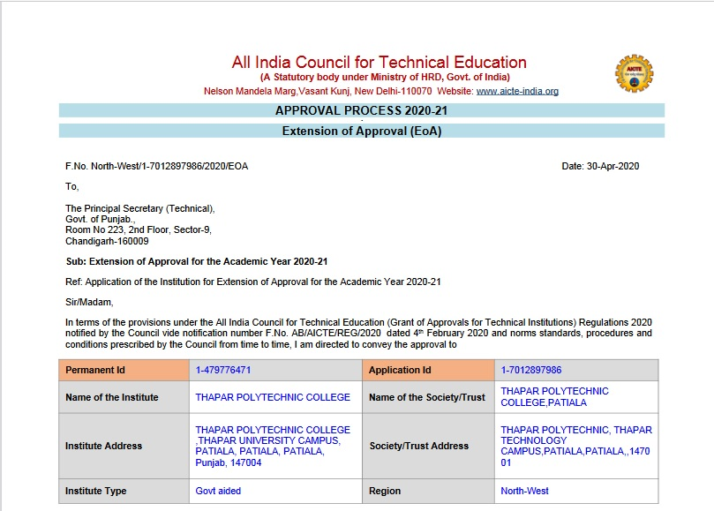
  - Number of students admitted under various categories each year in the last three years.
Courses | 2020 |  | 2019 |  | 2018
 | Sanctioned | Actual  2nd sem | Sanctioned | Actual  4th sem | Sanctioned | Actua  6th sem
A.A. | 60 | 8 | 60 | 17 | 60 | 20
Civil | 60 | 53 | 60 | 63 | 60 | 62
Electrical | 60 | 60 | 60 | 58 | 60 | 67
Mechanical | 60 | 50 | 60 | 59 | 60 | 56
E.C.E.* | 120 | - | 120 | - | 120 | 11
Computer | 120 | 110 | 120 | 102 | 120 | 91
I.T* | 30 | - | 30 | - | 30 | 6
*courses discontinued w.e.f academic session 2018-19
- Lateral Entry : Admission in second year Diploma course of appropriate program upto a maximum of 20% of sanctioned intake.
- Fee waiver seats shall be 5% over and above the sanctioned intake in Ist year.
Calendar for admission
i. Last date for request for applications. July (Every year)
ii. Last date for submission of application. Last/First week of July/ August (Every year)
iii. Dates for announcing final results. Second week of August (Every year)
iv. Release of admission list (main list and waiting list should be announced on the same day) Second week of August (Every year)
v. Date for acceptance by the candidate (time given should in no case be less than 15 days) Last week of August
vi. Last date for closing of admission. Last week of August
vii. Starting of the Academic session. As per academic calendar
viii The waiting list should be activated only on the expiry of date of main list.
ix The policy of refund of the fee, in case of withdrawal, is clearly notified.
- CRITERIA AND WEIGHTAGES FOR ADMISSION:
As per Board Guidelines.

XIII. LIST OF FACILITIES AVAILABLE:
a. Games and Sports Facilities
It has been rightly said that “ Health is Wealth” and to reduce the stress in today’s life it is believed that besides education some entertainment should also be there. Students at this institute are not only doing exceedingly well in the academics but are doing equally well in sports. They have brought laurels to the Institute many times in various sports events in the state. The various playgrounds available in the institute are: -
1. Cricket
2. Kabaddi
3. Kho-Kho
4. Volleyball
5. Hockey
XIV. TEACHING LEARNING PROCESS:
a. Curricula and syllabi for each of the programmes as approved by the Board | Curriculum designed and approved by the Board is followed for all the programmes.
b. Academic Calendar of the Board | www.punjabteched.com
c. Academic Time Table | Attached at Annexure-I
d. Teaching Load of each Faculty | As per AICTE guidelines
e. Internal Continuous Evaluation | Continuous internal evaluation system of students is followed as per Board guidelines. Regular record of each student is maintained in attendance –cum -Performance register by the faculty.
f. Teaching Learning Process
- Conducting practical using modern equipment
- Providing Calendar/Examination Schedule/Student Courses Files at the beginning of the academic year.
- Arranging special lectures by the Experts.
- Encouraging the students to participate in seminars.
- Industrial visits to get exposure and promote Institute-Industry interaction.
- Imparting leadership qualities, teamwork and communication skills to the students by organizing personality development courses and seminars.
- Informing parents about the progress of their wards periodically.
- Monitoring by periodic written feedback from the students.
- Using modern technical aids (Audio Visual).
- Interaction with the industries.
- Regular knowledge updating through Library and Reference work.
- Participate in Seminars.
- Self assessment and Faculty Feed back. .
- Sponsoring faculty for short term courses
XV. Student Feedback
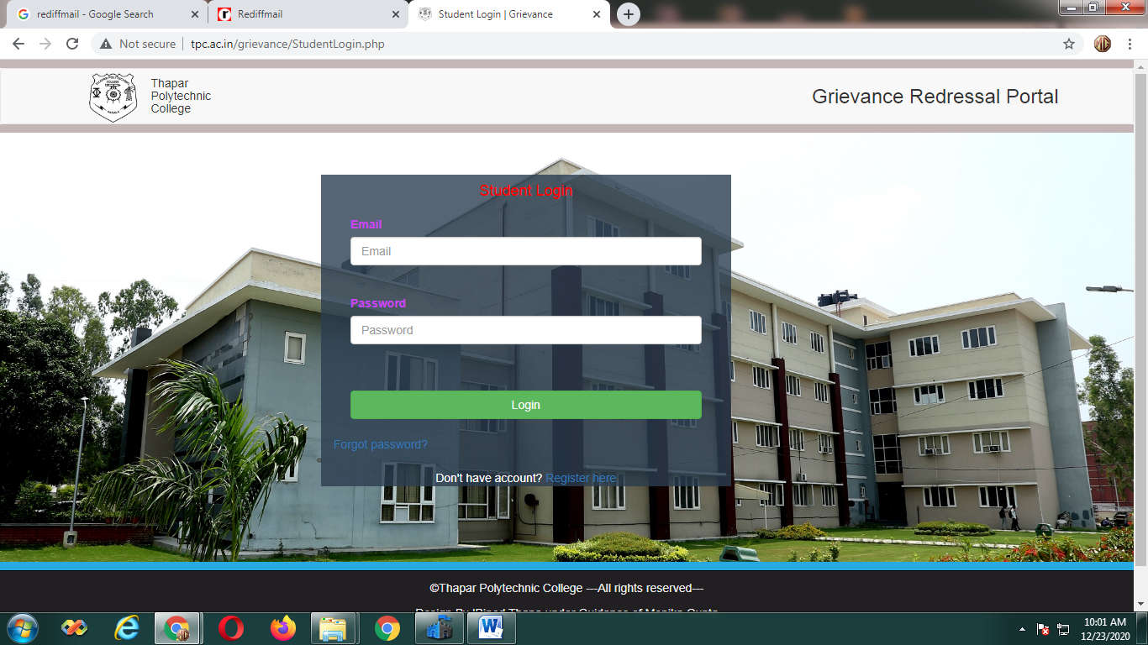
XVI. Faculty Feedback
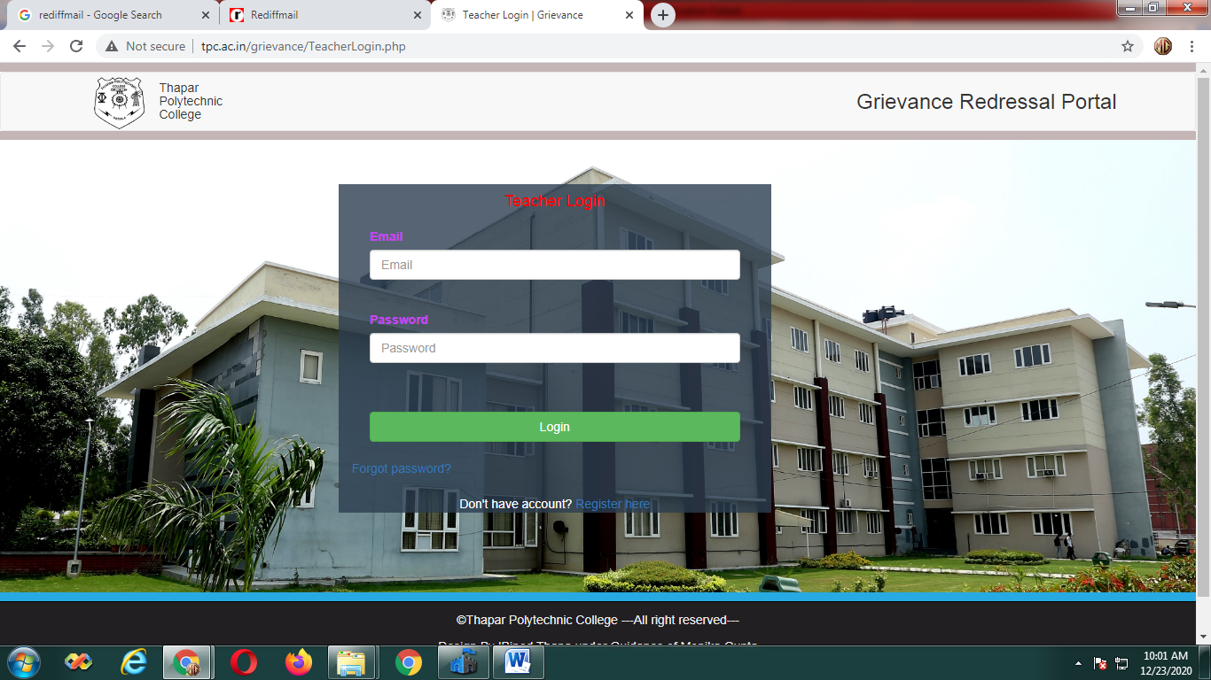
Principal
Thapar Polytechnic College, Patiala

