CHAPTER-4
LUBRICANTS
LUBRICANTS: These are the substances which are used to decrease the force of friction between the moving parts of machines in contact.
LUBRICATION: The process of decreasing force of friction between moving parts of machines by using lubricant is called lubricati: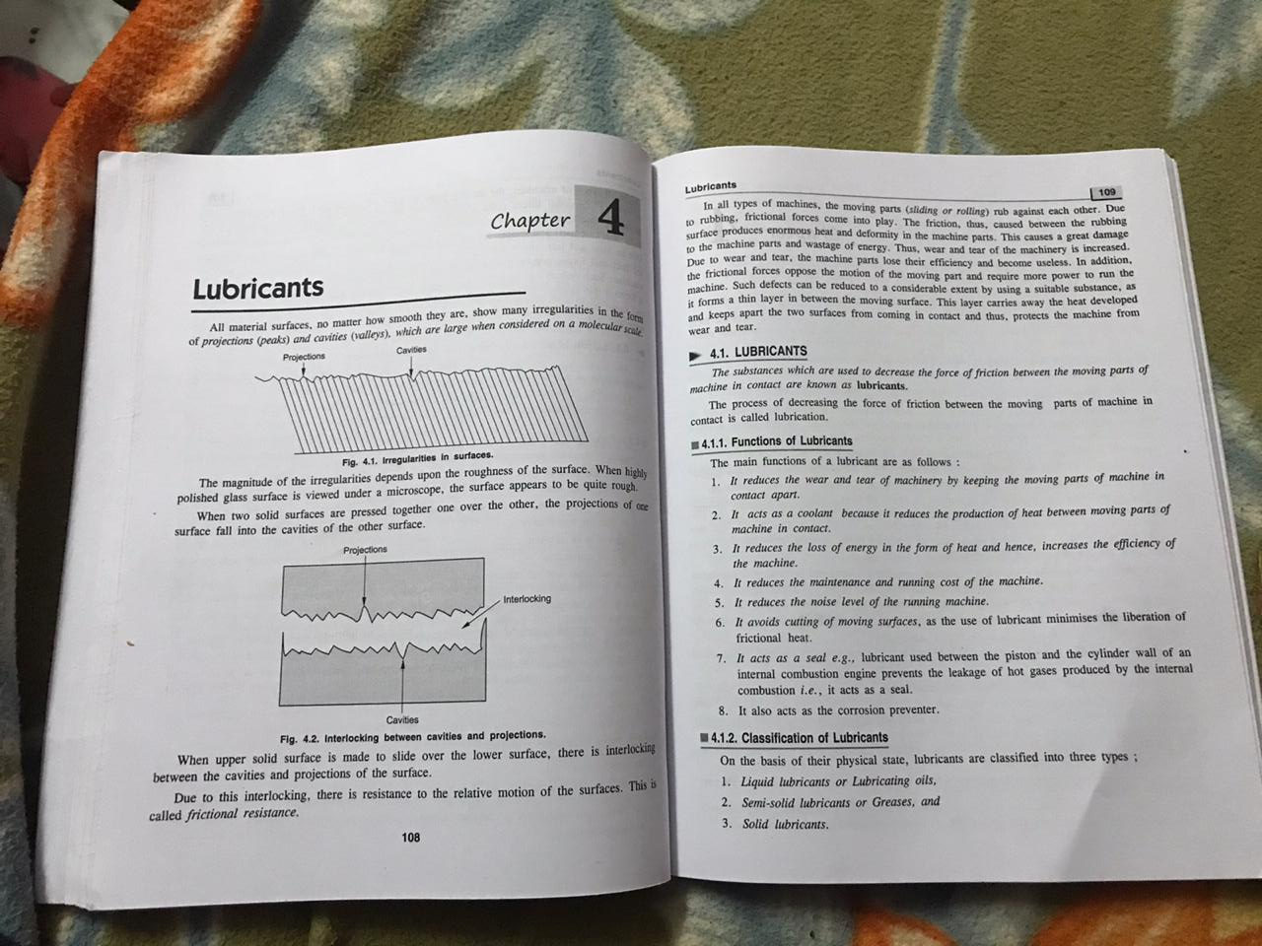ONLY READ ARROW MARKED PORTION.
CLASSIFICATION OF LUBRICANTS:
Lubricants can be classified as :
1.Liquid lubricants
2.Solid lubricants
3.Semi solid lubricants or greases
1.LIQUID LUBRICANTS OR LUBRICATING OILS: These are very good lubricants as they provide continuous fluid between moving parts of machines.They worked as :a)cooling agent b)Sealing agent and c)corrosion preventor.
The good lubricant should have following properties:
- Low vapour pressure and high boiling point
- High oxidation resistance
- Non corrosive nature
- Good thermal conductivity
- Low freezing point
- Accurate viscosity under particular condition.
They are further classified as:
- Mineral oils: They are also called petroleum oils and they are obtained by fractional distillation of petroleum at 400◦C.After distillation sometimes there are impurities like wax,asphalt etc which make it unfit for use.These impurities can be removed by following processes:
- Dewaxing: The oil should be cooled on temp less than 30◦C so that wax solidifies and easily filterted from oil by distillation.
- Acid refining: If dewaxed oil have further impurities than it is made to react with sulphuric acid and then separated and collected.Some of impurities get dissolved and some are converted into sludge and sludge is then pass through sodium hydroxide solution to remove excess of acid.Oil is then finally decolorised by passing through fuller’s earth at 110-140◦C.
- Solvent Refining: In this process the mineral oil now mixed with phenol because the unwanted impurities are more soluble in phenol than in oil .Phenol cannot mix with oil.The solution is kept aside for sometime undisturbed and after sometime different layers are formed and we can separate pure oil solvent from impurity layer by distillation.
2.Vegetable oils: They are obtained from vegetable sources and they are added to mineral oils to improve their properties. They can be classified as:

- Olive Oil :It is prepared from fruits of olive tree .It can be colourless to golden yellow.
- Palm oil: It is prepared from kernels of palm fruit and have pleasant smell and pale yellow colour.
- Castor oil: It can be prepared from seeds of castor . Its colour can colourless to pale green.
- Hazel nuts oil: It can be prepared from hazel nut seeds.
3.Animal oils : They can be prepared from animal sources and like vegetable oils they are also added in mineral oils to improve their properties.
They can be further listed as:
- Whale oil: It is thin oil which is yellow in colour and is prepared from whales.
- Lard Oil: It is colourless oil made from kidneys and intestines of pig.
- Tallow Oil: It is transparent oil and prepared from fat of cattles and sheeps.
4. Blended oils: These oils are obtained by mixing of mineral oil with vegetable oil to improve its properties. They are made to make mineral oil a good lubricant by improving its viscosity and resisting of oxidation and corrosion.
5. Synthetic Oils: When mineral oils fails , synthetic oils are used. They are chemically prepared and very costly. They are used in jet engines,rocket motors etc.
APPLICATIONS OF LIQUID LUBRICANTS:
- They are anti oxidants and anti foaming agents.
- They are emulsifying and demulsifying agents.
- They also reduces corrosion.
- They are used as machinery oils,gear oils etc.
- They are used as hydraulic,brake and gear box fluids.
- They are used in soap and paint industries.
- The synthetic lubricants are used in turbines, vaccum pumps and semi conductor devices
- They can also be used as cutting fluids in many industries.
SEMI SOLID LUBRICANTS OR GREASES: Greases are semi solid lubricants having soaps dispersed in petroleum oils. They may have waxes,fats and petroleum residues etc. in it. They can be classified according to nature of soap as follows:
1.Calcium based greases: They are water resistant and they are emulsions of petroleum and water in which calcium stearate or calcium oleate is added as stabliser.
2.Soda based greases: They are obtained by mixing sodium soaps with petroleum oil. They are not water resistant.
3.Lithium based greases: They are obtained by adding lithium based soaps to petroleum oil . They are water resistant and able to use at very low temp.
APPLICATIONS OF GREASES:
1.They can be used in machinaries which are stored for long time as grease can remain in place and immediately form lubricating films.
2. These greases can be used as seal formed lubricants life long in electric motors and gear boxes.
3. They can be used in heavy load machinery where there is high pressure , it can make good lubricating film whereas thin oil film can be broken.
4. Grease form thicker lubrication layer which can also provide noise insulation.
SOLID LUBRICANTS: These are the lubricants which are used when mineral oils and greases donot work. They work under conditions of:
1.Where lubricating film made of oil and greases are not secured.
2. Where there is dust or dirt particles , specially in electric motors and generators.
3. Where there is operating temperature is too high.
Mostly used solid lubricants are graphite and molybdenum disulphide (MoS₂):
- Graphite:It is most widely used solid lubricant. It is soapy in touch, non -inflammable and can not be oxidised below 385◦C.If it is dispersed in oil it is called oildag and if it is dispersed in water it is called aquadag. Oil dag is used in internal combustion engines and aquadag is used in food stuff industries.
- Molybdenum disulphide: It has very low coefficient of friction and is stable upto 430◦C. It is finely powdered and is sprinkled on surfaces of sliding machinery parts and is used with greases.
APPLICATION OF SOLID LUBRICANTS:
1.It is used in conditions of very high and very low temp. and pressures.
2. They are used in machinery which is stored for long time as they provide permanent and non corrosive lubrication.
3.They can be used of areas of heavy dust and dirt.
4. As they can not be shifted to one place to another place once they have applied so they donot contaminate other equipments.

