14th April 2020
- NEWSPAPER ACTIVITY – PART A
I. Put an appropriate title for the article given below and find out 5 or more difficult words in it and write their meanings: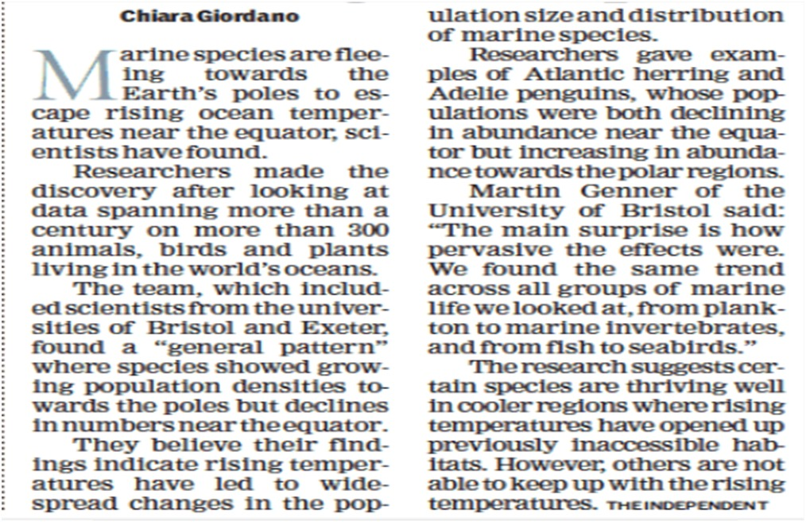
Appropriate title for the article: __________________________________________________
5 or more difficult word-meanings:
1) _________ 2) _________3) _________4) _________5) _________

II. Put an appropriate title for the article given below and find out 5 or more difficult words in it and write their meanings:

Appropriate title for the article: __________________________________________________
5 or more difficult word-meanings:
1) _________ 2) _________3) _________4) _________5) _________

III. Put an appropriate title for the article given below and find out 5 or more difficult words in it and write their meanings:

Appropriate title for the article: __________________________________________________
5 or more difficult word-meanings:
1) _________ 2) _________3) _________4) _________5) _________
IV. Put an appropriate title for the article given below and find out 5 or more difficult words in it and write their meanings:

Appropriate title for the article: __________________________________________________
5 or more difficult word-meanings:
1) _________ 2) _________3) _________4) _________5) _________

V. Put an appropriate title for the article given below and find out 5 or more difficult words in it and write their meanings:
“Psychology is the study of human behaviour in context. This context could have pathological dimension but increasingly, it has a problem-solving angle associated with it. Given the fact that human behaviour is extremely complicated and most repeated jobs are being taken over by machines, especially with the advent of the fourth industrial revolution, psychology graduates are increasingly finding lucrative jobs across a variety of industries. Shop floors, market research and consulting firms, technology companies such as Google and Amazon, industrial giants like GE and Samsung – all are extremely receptive to this new breed of problem-solvers. In our assessment, psychology graduates are getting slotted across four major job types–
Academic: A large percentage of psychology graduates are still oriented towards academic jobs. These jobs eventually culminate in a faculty position at a leading university and may have extensive research component associated with it. Leading behaviour scientists, though, tend to run their own consulting practice and guide organisations across a variety of fields.
Clinical: These psychology graduates are the ones who ‘cure’ people. These people usually require a license and accreditation from local authorities to run their practices. They usually work with people with a variety of disorders or behaviour aberrations – ranging from mild depression, autism or dyslexia to disruptive pathological conditions like bipolar personality disorder, schizophrenia, etc.
Non-Clinical advisory/counselling: Usually armed with a counselling degree and not necessarily a Masters in Psychology, these people assume advisory roles in a variety of contexts –school and college children, socially oppressed people or victims, marginalised sections of the society, and even mild therapy areas.
Applied behaviour in business: More prevalent roles in this domain range from researchers, business analysts, organisational coaches and HR generalists.
Psychology master’s programmes are on the way to becoming as popular as MBA courses and are looking at a major overhaul.”

Appropriate title for the article: __________________________________________________
5 or more difficult word-meanings:
1) _________ 2) _________3) _________4) _________5) _________

