SOLID FUEL: These are the fuels which are naturally occurring and are called primary solid fuels.for eg. Wood,coal etc.
WOOD: It is basically obtained from forest.
Composition of wood: Carbon= 50% Oxygen=43% Hydrogen=6% Nitrogen=1% Ash=0.5%-1%
Properties: 1. It burns with smoky flame.
2. It leaves ash after burning
3. Its calorific value is 3500-4500 kcal/kg
4. It have maximum volatile matter.
Uses: It is used as domestic fuel.In industries it can be used just in starting of heating process.
COAL: It is a fossil fuel which is produced from dead decay of living matter buried under high temperatures and pressures.It took billions of years to get produced.
Types of coal or Classification of coal:
Types of coal can be studied from their ranking or degree of coalification .
Wood-------- Peat---Lignite--Bituminuous Coal---Anthracite
The various types are explained as:
- PEAT:It is first stage after wood. Its color is brown or black. It have high moisture content which can be reduced by drying
Properties: Dried peat have calorific value of 4500-5400 kcal/kg. It is unfit for use in industry.
Uses: It is used as local fuel for domestic purpose.
- LIGNITE(BROWN COAL): It is second stage after wood. It have moisture content of upto 60% which can be reduced by drying.
Properties: It have high calorific value than peat.After drying it have calorific value of 6500-7100 kcal/kg
Uses: It is used for domestic purposes, in boiler feeds and also in manufacture of producer gas.
- Bituminuous Coal (Common coal): It is third stage after wood.It is dark in color and it gives luminous flame on burning.It has three forms which are:
- Sub-bituminous coal:Its colour is black and it have volatile and moisture content. It got crumble into pieces in air.It is very smooth in nature.Its carbon content is about 75-80% and it have calorific value of 7000kcal/kg.
- Bituminious coal(Banded) : It has carbon content of 80-90%. It have calorific value of 8500kcal/kg.It is used in industries,making of coal gas and domestic heating.
- Semi bituminuous coal: It is having Carbon content of 90-93% and low volatile content. It is used in manufacture of coke, It has calorific value of 8500-8600kcal/kg.
- Anthracite:It is final stage after transformation of wood to coal. It has highest carbon content and lowest volatile content.It is used for steaming purposes in boiler feeds. It have calorific value of almost 8700 kcal/kg.
ANALYSIS OF COAL
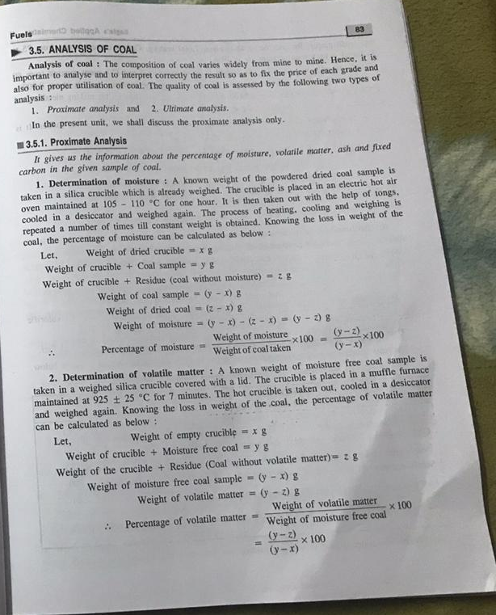
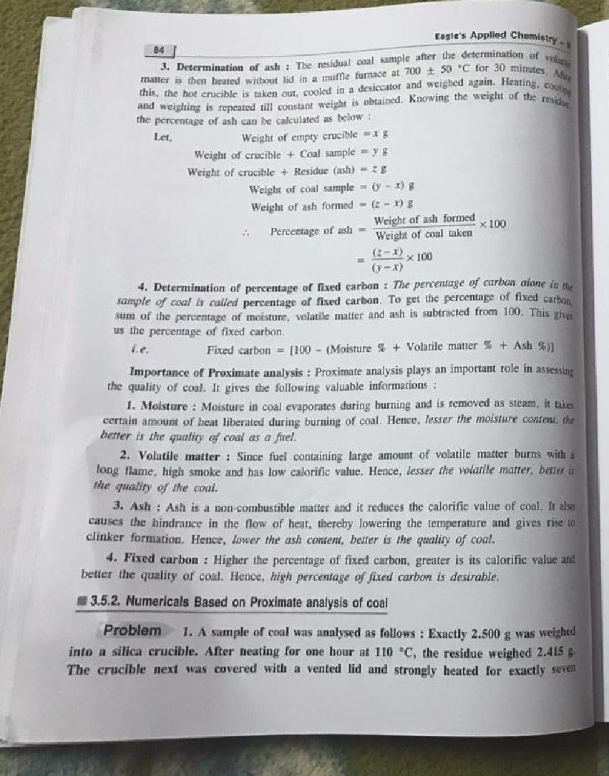
POWER ALCOHOL : It is the fuel which is formed by mixture of petrol(75-80%) and ethanol in fixed ratio.It is used for power generation in automobiles.It is also used instead of gasoline in India.
LIQUID FUELS: These fuels are very much useful for domestic as well as industrial purposes than solid fuels .Mostly, they are formed from petroleum and crude oil.
PETROLEUM: It is found in earth crust.It is dark green brown in colour.It is mixture of saturated and unsaturated hydrocarbons,paraffins,olefins and some aromatic compounds as well as some organic compounds having sulphur and nitrogen.
FUEL RATING(DETERMINATION OF QUALITY OF FUEL): The quality of fuels can be expressed by the numbers:
- Octane number(for petrol)
- Cetane number(for diesel)
OCTANE NUMBER(FOR PETROL): Octane number is the number which is used to express the quality of petrol or gasoline.Petrol or gasoline is mainly use as fuel to run automobiles.It gives the measure of antiknocking quality of fuel. Any fuel having more quantity of iso octane and less quantity of n-heptane is called good fuel.For eg. If the a fuel have antiknocking quality of 80% it means it has 80% octane and 20% n-heptane (by volume).All good quality fuels have octane no. 80 or more than 80.Octane number can be increased by addition of poisonous substances like tetraethyllead(TEL). The addition of such poisonous substances can lead to pollution as they produce many harmful gases like nitrogen dioxides,sulphur dioxides,CO etc.
If the structure is considered than octane no. changes as:
Simple straight chain<Branched chain alkanes<Alkenes<Cycloalkanes<Aromatic
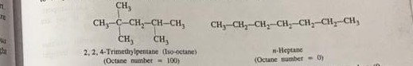
CETANE NUMBER: It is the number which is used to express the quality of diesel. Cetane is saturated hydrocarbon. Its chemical name is n-hexadecane. The Cetane number of n-hexadecane is 100. Its ignition lag is very less while if there is present methyl naphthalene its cetane number is 0, Its ignition lag is vey high. Therefore cetane no. is the %age of cetane by volume present in mixture of n-hexadecane and methyl naphthalene. If any diesel fuel have cetane no. more than 80 , then it is good fuel. For eg.: If we have diesel whose cetane no. is 80 it means cetane is present 80% by volume and methyl naphthalene is present 20% by volume. It can be increased by adding small amount of ethyl nitrate, acetone etc.
If the structure is considered than cetane no. changes as:
Simple straight chain>Branched chain alkanes>Alkenes>Cycloalkanes>Aromatic

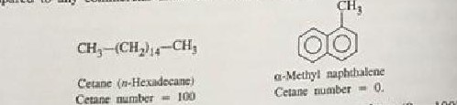
The fuels which are poor gasoline or petrol fuels are good diesel fuels.

GASEOUS FUELS :Gaseous fuels are very much preferred over solid as well as liquid fuels.
