CHAPTER-3
FUELS
Definition of Fuels: These are the substances which are combustible and when burnt in air produce high amount of energies which can be used for domestic as well as industrial purposes.For eg. Wood,Coal,Petrol,Charcoal etc.
Combustion of fuels: When any substance is burnt in air in the presence of oxygen it is called combustion.For eg.
C(s)+O₂--CO₂
The min. temperature at which substance catches fire and burns is called IGNITION TEMP.
How can fuels be classified?
Fuels can be classified as:
On the basis of occurrence fuels can be classified as:
1.Natural fuels: Fuels which occur naturally are natural fuels. For eg. Wood,coal etc.
2.Artificial fuels or secondary fuels: Fuels which are prepared artificially are called as artificial fuels.For eg. Charcoal,petrol gas etc.
On the basis of physical state the fuels can be classified as:
1.Solid fuels: Wood,coal,charcoal etc.
2.Liquid fuels: Crude oil,Petrol,diesel etc.
3.Gaseous fuels: Natural gas,Coal gas ,Water gas etc.
What are the units of heat?
Heat is measured in:
- Calorie (cal)
1kcal=1000cal
- B.Th.U.(British thermal unit)
1kcal= 3.968 B.Th.U
- Joules(J):
1cal=4.184 joules
What are the characteristics of good fuel?(v.v.imp)
1.A good fuel should have high calorific value i.e it should produce more amount of heat
2.It should have low moisture content because have moisture content decreases calorific value of fuel
3.It should not produce poisonous gases like CO,SO₂ etc. on heating.
4.It should be cheap and available.
5.It should have low storage cost.
6.It should have highest pyrometric effect.(high temp. can be obtained)
7.It is easy to transport and handle.
8.It is easy to control to combustion of good fuel.

COMPARISON OF SOLID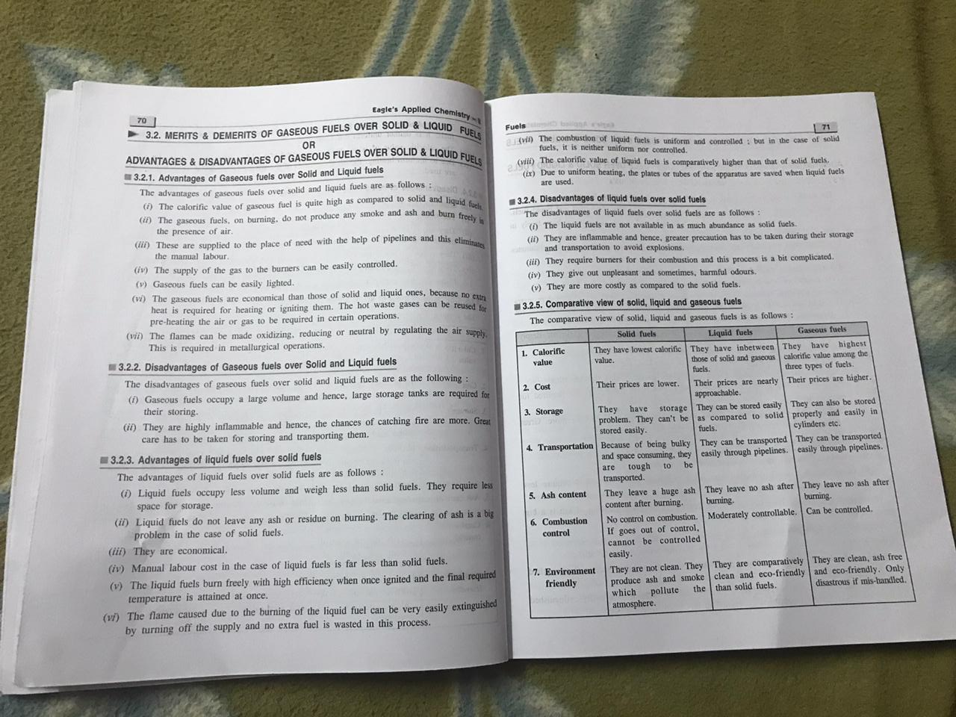, LIQUID AND GASEOUS FUELS(From book)
Advantages and disadvantages (from book)

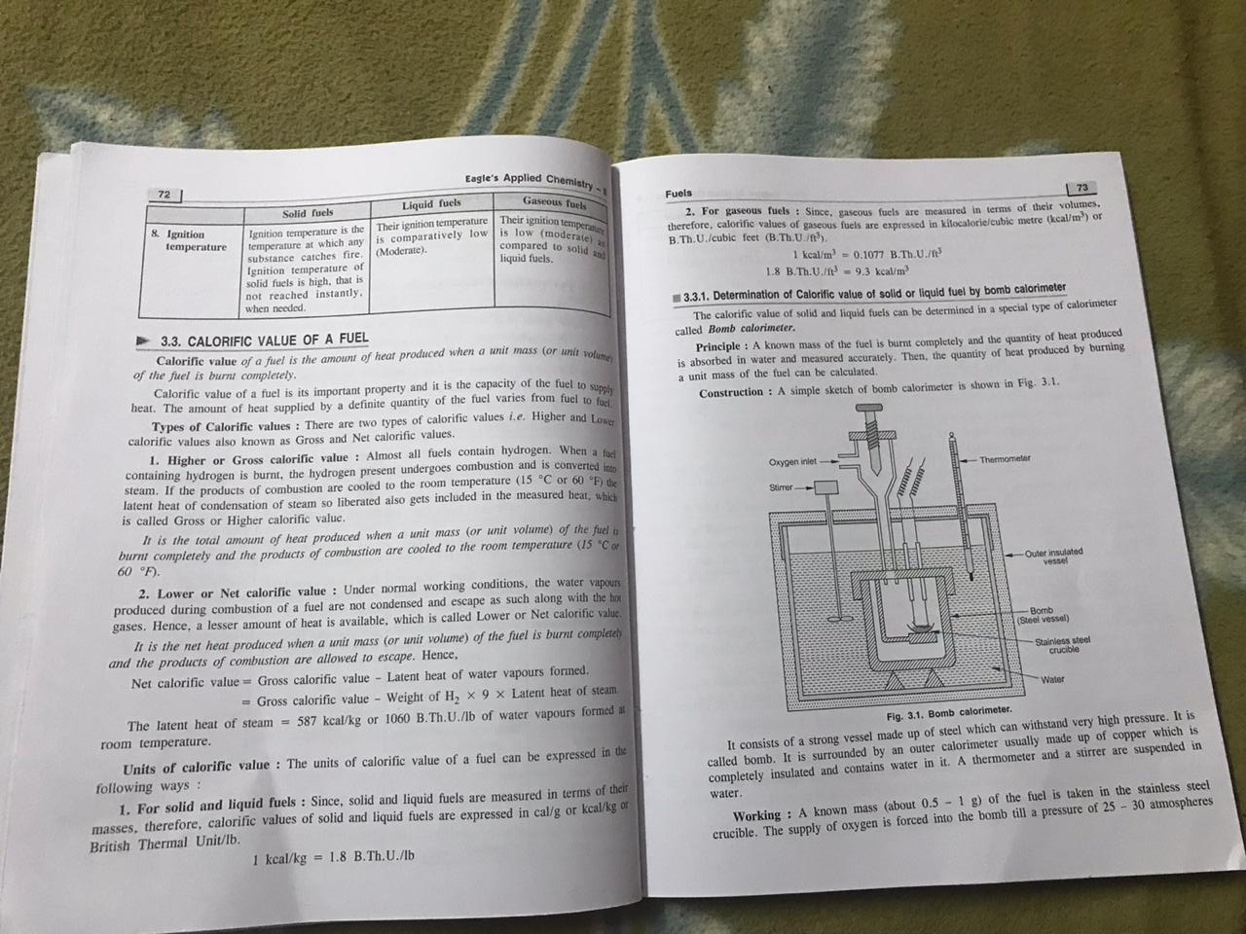

* Students only learn the yellow marked lines from above.

WHAT IS BOMB CALORIMETER? WHAT IS ITS WORKING OR APPLICATION?
Bomb calorimeter is the device which can be used to measure calorific value of solid and liquid fuels.
Principle of bomb calorimeter: It works on the principle that the quantity of heat produced by unit mass of fuel can be measured by heating it properly and then the released heat will be absorbed in water .
*Diagram from book(as shown in above picture)
Construction: It is having a bomb i.e the steel vessel which can bear high pressures and outside this there is present water in the insulated calorimeter made up of copper.There are also thermometer and stirrer hanged in water.*Students only read yellow underlined part.
Working: (from book)
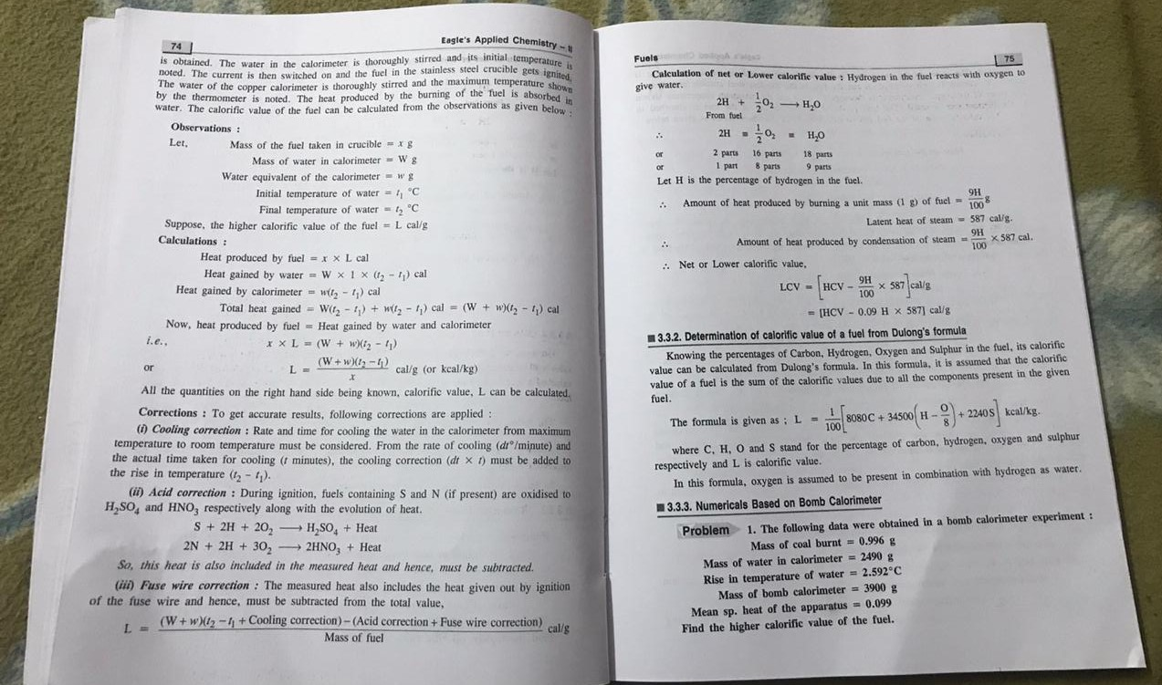

*Students only read yellow underlined part.

